REINFORCEMENT LEARNING
1. Introduction to Reinforcement Learning
Reinforcement Learning: Key features and Elements of RL, Types of RL, rewards. Reinforcement Learning Algorithms: Q-Learning, State Action Reward State action (SARSA)
PAST QUESTIONS:
- Explain types of reinforcement learning. (M24)
- Define reinforcement learning and explain the key components involved in the RL framework. (M24)
- Define Offpolicy algorithm and onpolicy algorithm and identify SARSA in which type of algorithm and why? Write SARSA algorithm in detail? (M25)

NOTES:

*Types of RL :-
Reinforcement Learning (RL) is a branch of machine learning that focuses on how agents should act in an environment to maximize cumulative rewards. It is inspired by behavioural psychology, where agents learn through interaction with the environment and feedback. RL has shown promising results in robotics, game-playing AI, and autonomous vehicles.
Types of Reinforcement Learning –
1.Value Based –
Value-based reinforcement learning focuses on finding the optimal value function that measures how good it is for an agent to be in a given state (or take a given action). The goal is to maximize the value function, which represents the long-term cumulative reward. The most common technique in this category is Q-learning, DQN.
2. Policy Based –
Directly optimizes the policy (strategy) to select actions without needing a value function. It is often used for complex or continuous action spaces.
Directly learn a policy function that maps state to action. These methods can be effective for environments with high-dimensional or continuous action spaces, where value-based methods struggle. Algorithms like REINFORCE, Proximal Policy Optimization (PPO) uses this technique.
3. Model Based –
The agent builds an internal model of the environment (transition dynamics and reward function) and uses it to plan.
Model-based RL introduces an explicit model of the environment to predict the future states and rewards. The agent uses the model to simulate different actions and their outcomes before actually interacting with the environment. This helps the agent plan actions more effectively. Techniques like Model Predictive Control (MPC), World Models.
4. Model Free –
The agent learns directly by taking actions and receiving rewards, without building an explicit, predictive model of the environment. For example, Deep Q-Network (DQN) is a model-free reinforcement learning technique.
*Q-Learning :-
Q-learning is a model-free, value-based, off-policy algorithm that will find the best series of actions based on the agent's current state. The “Q” stands for quality. Quality represents how valuable the action is in maximizing future rewards.
Q-Learning is a popular model-free reinforcement learning algorithm that helps an agent learn how to make the best decisions by interacting with its environment. Instead of needing a model of the environment the agent learns purely from experience by trying different actions and seeing their results.
Key Components –
- States(s): the current position of the agent in the environment.
- Action(a): a step taken by the agent in a particular state.
- Rewards: for every action, the agent receives a reward and penalty.
- Q-Table: The agent will use a Q-table to take the best possible action based on the expected reward for each state in the environment.
- Q-values: Q-values represent the expected rewards for taking an action in a specific state. These values are updated over time using the Temporal Difference (TD) update rule.
- Episodes: the end of the stage, where agents can’t take new action. It happens when the agent has achieved the goal or failed.
- Temporal Differences (TD): used to estimate the expected value of Q(S_{t+1}, a) by using the current state and action and previous state and action.
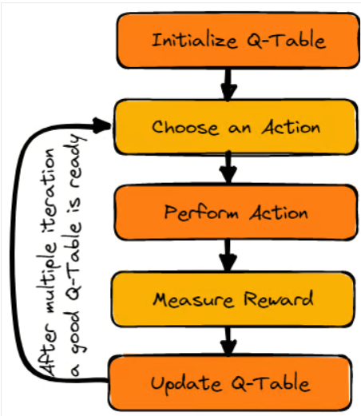
Working –
Let us consider an agent that has to cross the frozen lake from the start to the goal, without falling into the holes. The best strategy is to reach goals by taking the shortest path.
1. Initialize Q-Table -
We will first initialize the Q-table. We will build the table with columns based on the number of actions and rows based on the number of states.
In our example, the character can move up, down, left, and right. We have four possible actions and four states(start, Idle, wrong path, and end). You can also consider the wrong path for falling into the hole. We will initialize the Q-Table with values at 0.
2. Choose an Action -
The second step is quite simple. At the start, the agent will choose to take the random action (down or right), and on the second run, it will use an updated Q-Table to select the action.
3. Perform an Action -
Choosing an action and performing the action will repeat multiple times until the training loop stops. The first action and state are selected using the Q-Table.
With every move, we will be updating values in the Q-Table using the Bellman equation and also using it for determining the best course of action.
4. Measuring the Rewards -
After taking the action, we will measure the outcome and the reward.
- The reward for reaching the goal is +1
- The reward for taking the wrong path (falling into the hole) is 0
- The reward for Idle or moving on the frozen lake is also 0.

5. Update Q-Table -
We will update the function Q(S_{t}, A_{t}) using the equation. It uses the previous episode’s estimated Q-values, learning rate, and Temporal Differences error. Temporal Differences error is calculated using Immediate reward, the discounted maximum expected future reward, and the former estimation Q-value.
The process is repeated multiple times until the Q-Table is updated and the Q-value function is maximized.
Over time the agent learns the optimal policy that consistently yields the highest possible reward in the environment.
*SARSA :-
SARSA (State-Action-Reward-State-Action) is an on-policy reinforcement learning (RL) algorithm that helps an agent to learn an optimal policy by interacting with its environment. The agent explores its environment, takes actions, receives feedback and continuously updates its behavior to maximize long-term rewards.
The main idea behind SARSA is trial and error. The agent takes an action in a situation, observes the result, and adjusts its strategy based on the outcome (good or bad). This process is repeated many times, leading to improvements in the agent’s decisions over time.
Unlike off-policy algorithms like Q-learning which learn from the best possible actions, it updates its knowledge based on the actual actions the agent takes. This makes it suitable for environments where the agent's actions and their immediate feedback directly influence learning.
It is like a robot learning to ride a bike by actually riding it, falls and all, instead of finding the shortest path from A to B by using protective training wheels.
Key components of SARSA –
- State (S): The current situation or position in the environment.
- Action (A): The decision or move the agent makes in a given state.
- Reward (R): The immediate feedback or outcome the agent receives after taking an action.
- Next State (S'): The state the agent transitions to after taking an action.
- Next Action (A'): The action the agent will take in the next state based on its current policy.
- Discount Factor (γ): Determines how much importance is given to future rewards compared to immediate rewards.
SARSA focuses on updating the agent's Q-values (a measure of the quality of a given state-action pair) based on both the immediate reward and the expected future rewards.
SARSA updates the Q-value using the Bellman Equation for SARSA:
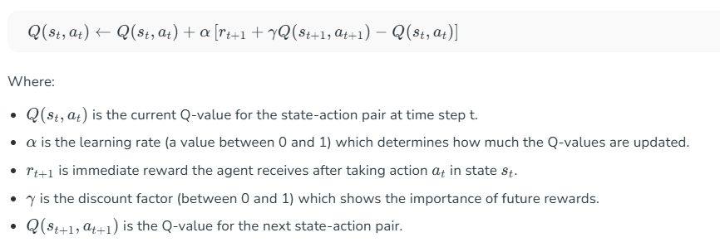
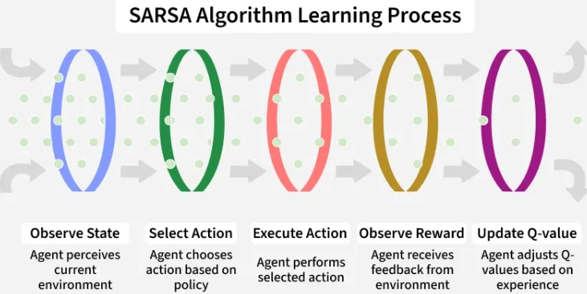
SARSA Algorithm Steps -
1. Initialize Q-values: Begin by setting arbitrary values for the Q-table (for each state-action pair).
2. Choose Initial State: Start the agent in an initial state $s_{0}$.
3. Episode Loop: For each episode (a complete run through the environment) we set the initial state $s_{t}$​ and choose an action $a_{t}$​ based on a policy like $ε$.
4. Step Loop: For each step in the episode:
- Take action $a_{t}$​ observe reward $R_{t+1}$​ and transition to the next state $s_{t+1}$​.
- Choose the next action $a_{t+1}$​ based on the policy for state $s_{t+1}$.
- Update the Q-value for the state-action pair $\left(s_{t} , a_{t}\right)$ using the SARSA update rule.
- Set $s_{t}=s_{t+1}$​ and $a_{t}=a_{t+1}$​.
5. End Condition: Repeat until the episode ends either because the agent reaches a terminal state or after a fixed number of steps.

